FE –CSE-AIML

Assignment 1 Unit 1- DC circuits (AY 2025-26)

Q1. Using SPT, find voltage across 4Ω resistor.
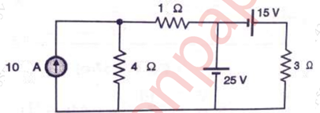

Q2. State and prove the maximum power transfer theorem. Derive the formula
of maximum power delivered to the load R_{L.}
Q3. Using Norton’s theorem calculate the current through 3ohm resistor across
the terminals A and B in the given circuit.
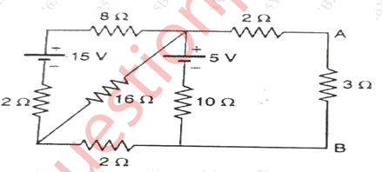

Q4. Define KVL. Find value of R3 in the figure given below by applying
Kirchhoff’s laws.
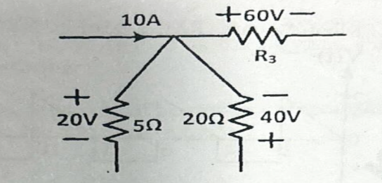

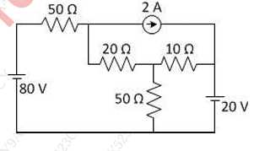
Q5. Find current in 10 ohms resistor

Q6. Find resistance across x and y
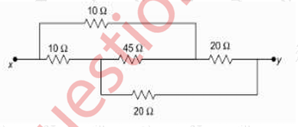

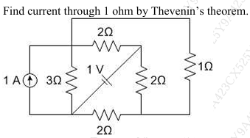
Q7. Find current through 1 Ohm by Thevenins theorem.

Course teacher

Dr. Nirmala K

